# [TBD NAME] Dating App

Person 1 =

Person 2 =

Person 3 =

# INT. Office – Day

Two Individuals are discussing regarding the struggle of their dating life. **Person 1** suggests a newly made app idea which could increase their chances in finding what they are really looking for.

PERSON 2

* Stating facts about personal dating life, wants a solution.

PERSON 1

* Suggests new idea, gives facts on where competitors are failing statistically and what we will do to combat/compete with them.

PERSON 3

* Wants to hear more, has some questions.

# INT. Investor Meeting – Day

The two Individuals take interest in this new idea. They hold an investor meeting and listen to the pitch **Person 1** has prepared.

PERSON 1

Introduction – what the program is.

* Who the market is.
* How is it different from what is out there already.

INVESTOR 1

* Asks questions (somewhat focused on how it makes money for them)

PERSON 1

* More of a breakdown as to how money will be made.
* Solidifies that an investment with us is the right choice. (Y)

INVESTOR 2

Raises any further concerns.

PERSON 1

Addresses at the further concerns

# INT. Pitch Party – Night

After a successful meeting, **Person 1**, **Person** 1’s friends and **Person 2** celebrate the launch of their new app.

* End of night Jack threw up on Sean.

# Storyboard

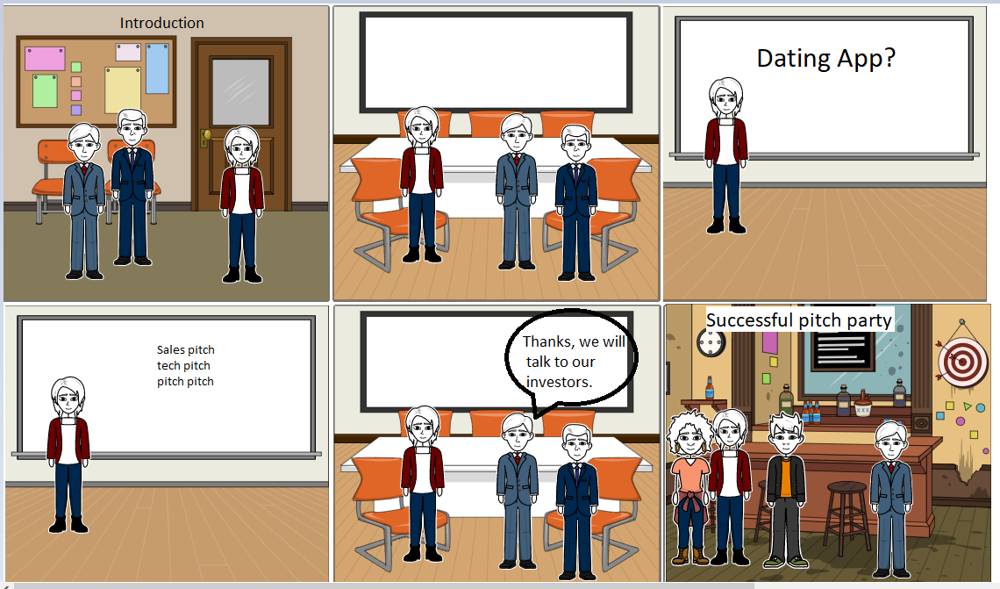

Made by Jack Holliday